ADOPTED – SEPTEMBER 23, 2025
AGENDA ITEM NO. 33

Introduced by the Human Services and Finance Committees of the:

INGHAM COUNTY BOARD OF COMMISSIONERS

RESOLUTION TO AUTHORIZE ENTRY OF PARTICIPATION AGREEMENTS IN PARTIAL SETTLEMENT OF THE NATIONAL PRESCRIPTION OPIATE LITIGATION AND ENTRY OF STATE LOCAL GOVERNMENT INTRASTATE AGREEMENT CONCERNING ALLOCATION OF SETTLEMENT PROCEEDS

RESOLUTION #25 – 445

WHEREAS, the Ingham County filed a lawsuit to address the public nuisance that is the Opioid Epidemic, which named, among others, Purdue Pharma L.P. (Purdue) and several members of the Sackler family (Sackler Family Defendants); and

WHEREAS, Purdue has presented a proposed Bankruptcy Plan, and the Sackler Family Defendants have entered into a Governmental Entity & Shareholder Direct Settlement Agreement (together, the “Purdue/Sackler Settlement”) with the State Attorneys General and a Plaintiff Executive Committee-designated negotiating committee that represents approximately 4,000 local governments that have brought lawsuits similar to Ingham County’s lawsuit; and

WHEREAS, the Purdue/Sackler Settlement will provide significant equitable and monetary relief, including an agreement that (a) the Sackler Family Defendants will pay $6.5 billion over the next 15 years in exchange for the release of claims against them and (b) the Purdue estate will contribute an amount of approximately $900 million; and

WHEREAS, the bulk of these payments will be dedicated to funding abatement and prevention strategies associated with the opioid public nuisance; and

WHEREAS, Ingham County previously executed Participation Agreements for the Distributor and Janssen Settlements, as well as the Teva, Allergan, CVS, Walmart, and Walgreens Settlements, which have conferred and continue to confer valuable benefits; and

WHEREAS, Ingham County desires to enter into an allocation method which allocates settlement funds on a 50/50 basis to:

- Participating Local Governments who have elected to participate in the Purdue/Sackler Settlement; and
- the State of Michigan.

THEREFORE BE IT RESOLVED, that Ingham County authorizes the Chairperson of the Board of Commissioners to execute a Participation Agreement for the Purdue/Sackler Settlement, which is available at https://nationalopioidsettlement.com/; a specimen copy of the material terms of the participation agreement is attached as Exhibit A to this resolution.

BE IT FURTHER RESOLVED, that Ingham County also authorizes the execution, by the Board Chairperson, of a new Michigan State-Subdivision Agreement for Allocation of Opioid Settlement Agreements substantially similar to the proposed agreement attached as Exhibit B to this resolution.

BE IT FURTHER RESOLVED, that Ingham County also authorizes the Weitz & Luxenberg law firm to vote on Ingham County’s behalf in favor of the Bankruptcy Plan for Purdue.

HUMAN SERVICES: Yeas: Tennis, Cahill, Trubac, Morgan, Willis, Ruest, Schafer
Nays: None Absent: None Approved 09/15/25

FINANCE: Yeas: Morgan, Grebner, Sebolt, Polsdofer, Cahill, Maiville, Ruest
Nays: None Absent: Tennis Approved 09/17/25
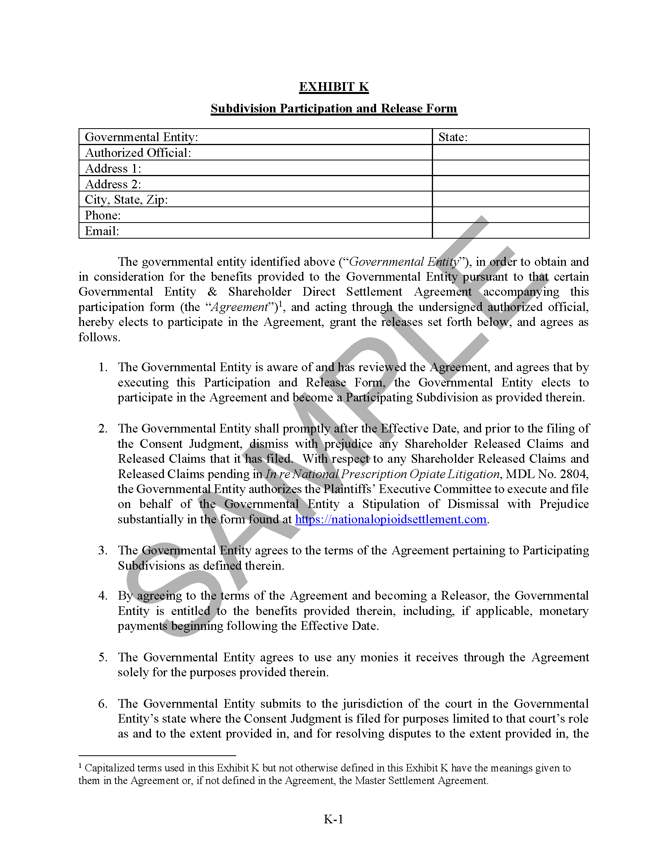
Exhibit A
